**BCD to 7 Segment Decoder**

**7 segment** display is an electronic device which consists of seven LEDs arranged in some definite pattern, which is used to display Hexadecimal numerals. But, 7 segment display does not work by directly supplying voltage to different segments of LEDs. First, our decimal number is changed to its BCD equivalent signal then BCD to 7 segment decoder converts that signals to the form which is passed to the 7 segment display. This BCD to seven segment decoder has four input lines (A, B, C, D) and 7 output lines (a, b, c, d, e, f, g)

**Truth Table**

|  |  |  |  |  |  |  |  |  |  |  |
| --- | --- | --- | --- | --- | --- | --- | --- | --- | --- | --- |
| A | B | C | D | a | b | c | d | e | f | g |
| 0 | 0 | 0 | 0 | 1 | 1 | 1 | 1 | 1 | 1 | 0 |
| 0 | 0 | 0 | 1 | 0 | 1 | 1 | 0 | 0 | 0 | 0 |
| 0 | 0 | 1 | 0 | 1 | 1 | 0 | 1 | 1 | 0 | 1 |
| 0 | 0 | 1 | 1 | 1 | 1 | 1 | 1 | 0 | 0 | 1 |
| 0 | 1 | 0 | 0 | 0 | 1 | 1 | 0 | 0 | 1 | 1 |
| 0 | 1 | 0 | 1 | 1 | 0 | 1 | 1 | 0 | 1 | 1 |
| 0 | 1 | 1 | 0 | 1 | 0 | 1 | 1 | 1 | 1 | 1 |
| 0 | 1 | 1 | 1 | 1 | 1 | 1 | 0 | 0 | 0 | 0 |
| 1 | 0 | 0 | 0 | 1 | 1 | 1 | 1 | 1 | 1 | 1 |
| 1 | 0 | 0 | 1 | 1 | 1 | 1 | 1 | 0 | 1 | 1 |

* For Common Anode type seven segment LED display, we only have to interchange all ‘0s’ and ‘1s’ in the output side and solve using K-map.
* Output for first combination of inputs (A, B, C, D) in Truth Table corresponds to ‘0’ and last combination corresponds to ‘9’. Similarly rest corresponds from 2 to 8 from top to bottom.
* BCD numbers only range from 0 to 9, thus rest inputs from 10-F are invalid inputs.
* We require seven separate segment connections plus one additional connection for the LED’s “common” connection.

**K-map**

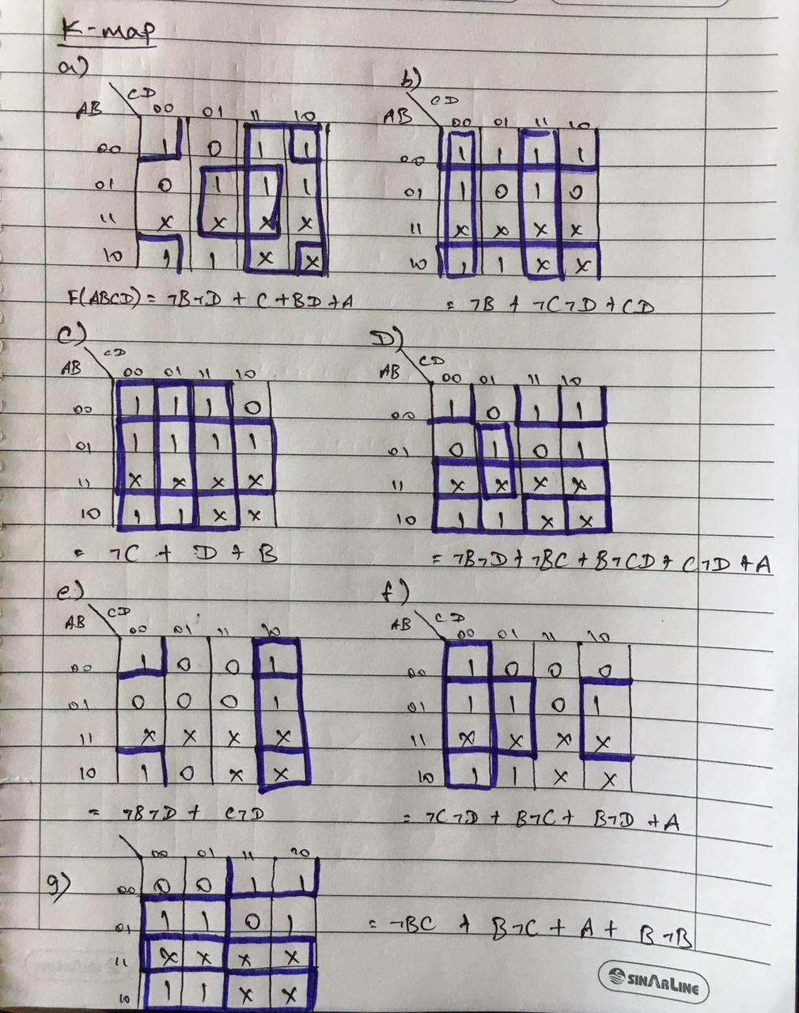

**Circuits for 7 segment decoder**

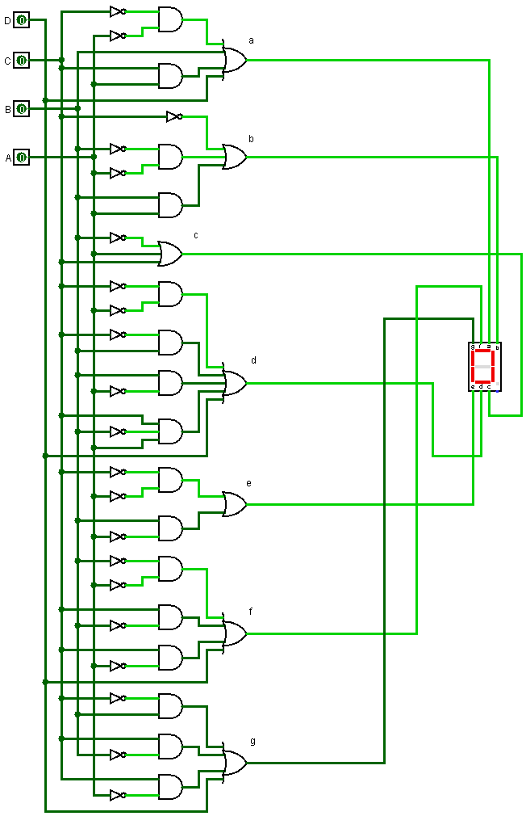

**Simulation**

